Morphological Operations Using Top Hat
Experiment No: 34
Aim
To perform the morphological Top Hat operation on an image using OpenCV in Python.
Tools Required
- Python 3.x
- OpenCV (cv2)
- NumPy
- VS Code / PyCharm / Jupyter Notebook
- Input image (image.jpg)
Theory
The Top Hat morphological operation is used to extract small bright objects or details from an image.
It is calculated by subtracting the Opening of the image from the original image.
OpenCV provides the cv2.MORPH_TOPHAT operation to perform this directly.
Procedure
- Install OpenCV and NumPy:
Bash
pip install opencv-python numpy
- Read the input image using OpenCV.
- Convert the image to grayscale.
- Create a structuring element (kernel).
- Apply the Top Hat operation using cv2.morphologyEx().
- Display the original and Top Hat images.
- Save the resulting image.
Code
import cv2
import numpy as np

# Read the image
image = cv2.imread("image.jpg")

# Check if image is loaded
if image is None:
print("Error: Image not found!")
exit()

# Convert image to grayscale
gray = cv2.cvtColor(image, cv2.COLOR_BGR2GRAY)

# Create a structuring element
kernel = np.ones((5, 5), np.uint8)

# Perform Top Hat operation
top_hat = cv2.morphologyEx(
gray,
cv2.MORPH_TOPHAT,
kernel
)

# Display original image
cv2.imshow("Original Image", gray)

# Display Top Hat image
cv2.imshow("Top Hat Image", top_hat)

# Save the output
cv2.imwrite("top_hat_image.jpg", top_hat)

cv2.waitKey(0)
cv2.destroyAllWindows()
Output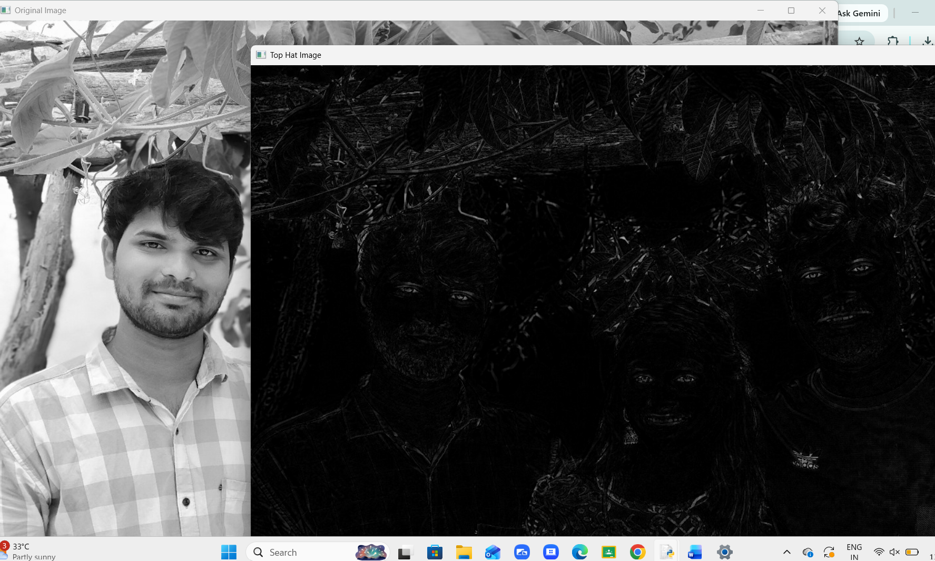
Result
The morphological Top Hat operation was successfully performed using OpenCV. The operation extracted small bright regions and fine details from the image by subtracting the morphological opening from the original image.

